# Table of Contents

Table of Contents 1

Business Rules 2

Restaurants ERD 3

ERD from DBeaver 4

SQL Queries 5

Sale made at Chicken Liken by cashier Palesa: 5

Sale made at KFC by cashier Kabelo: 5

All the sales from Chicken Liken and sales from KFC: 6

# Business Rules

* A restaurant is a franchise of different branches (franchisees).
* Each branch (franchisee) belongs to one and only one restaurant (franchise).
* A branch is located at a restaurant location which is the physical address of the branch.
* A branch is managed by only one employee with a manager role.
* Not all employees are managers.
* An employee only works for one branch.
* An employee can capture or record a transaction (record a sale) working at a till point only when he or she has cashier role.
* Not all employees can work as at the till as cashiers, therefore not all employees will record sales/transactions.
* If an employee resigns or is fired, no record of him/her is to be removed, instead the record is ticked as deleted. Record of the cashier employee are to persist in the sales record/transaction record for historical purpose.
* One or more transactions (sales) belong to only one branch. In case where the cashier employee is moved to a different restaurant branch, the transactions continue to be of that branch.
* A transaction record must keep track of multiple quantities of a menu item sold and different other items sold.
* Each item sold must have at least one transaction record with it.
* Each item sold is associated with only on menu item.
* Each menu item that may be removed from the menu item, is not permanently removed from the menu items list/record for historical purpose.

# Restaurants ERD

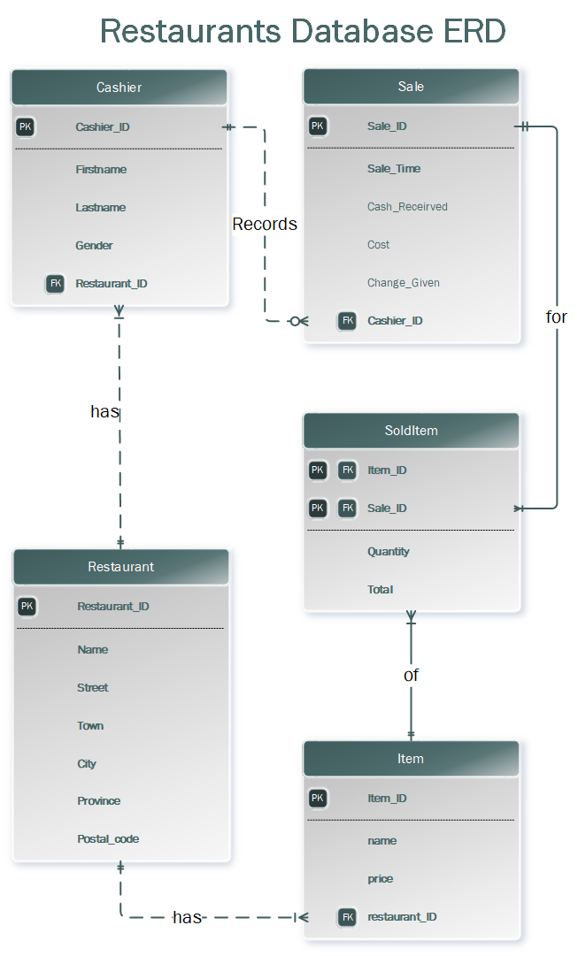

# ERD from DBeaver

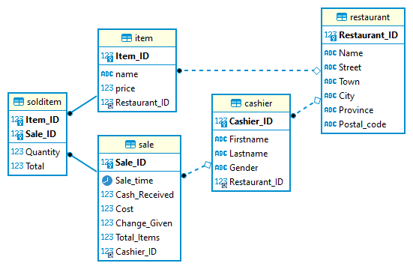

# SQL Queries

## Sale made at Chicken Liken by cashier Palesa:

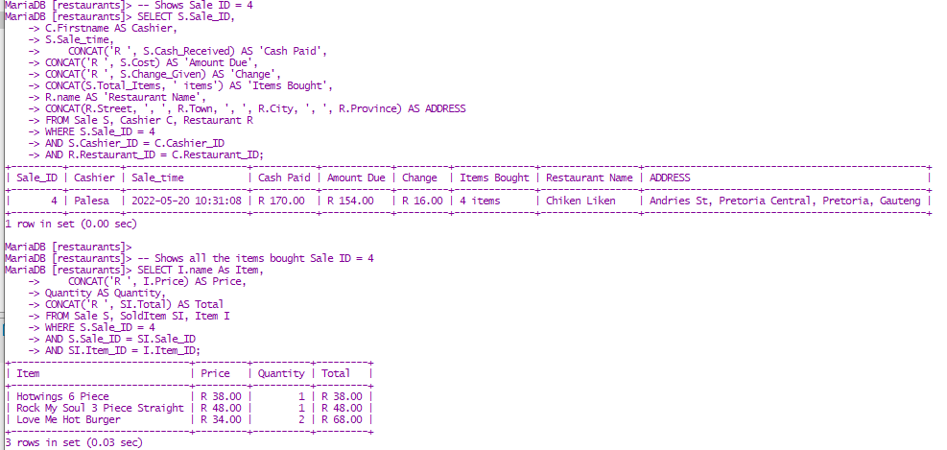

## Sale made at KFC by cashier Kabelo:

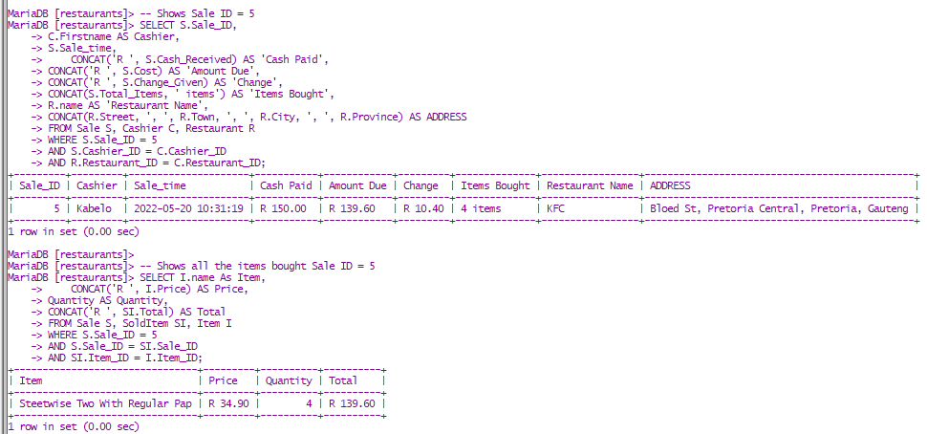

## All the sales from Chicken Liken and sales from KFC:

